**PHASE - 5**

**Big Data Analysis with IBM Cloud Databases**

**Project Objective:**

Utilize IBM Cloud Databases for real-time stock data storage and analysis, implementing the Random Forest algorithm to predict stock prices. This project aims to empower investors with accurate and actionable insights for informed investment decisions, leveraging big data analysis and the cloud's scalability.

**Design thinking and developmental phases :**

**Step 1 :**  Import all the libraries that are required for the creating the model.

**Step 2 :** Import the dataset which is extracted from the kaggle or from any other sources.

**Step 3 :** Check for the null values and check the datatype for each column if the date column is in the form of string means convert it into date format.

**Step 4 :** Define the start and end date from the dataset.

**Step 5 :** Plot the graph for the closing price of the dataset with date as x-axis and closing price as y-axis and scale down the dataset from 0 to 1.

**Step 6 :** Split the dataset into training and testing dataset.

**Step 7 :** Print the number of values in training and testing dataset .The training dataset should be more when compared to testing dataset.

**Step 8 :** Print the training and testing dataset’s RMSE,MSE,MAE,variance regression score,R2 score,MGD score,MPD score.

**Step 9 :** Evaluate the model for calculating the predicted closing price.

**Step 10 :** Finally Graph the Original and Predicted closing price of the stock.

**Dataset:**

* The dataset is extracted from the kaggle.
* The dataset consists of price of stock from the past years.



**Analysis techinique and visualization:**

**Time series analysis**

**Importing Libraries:**

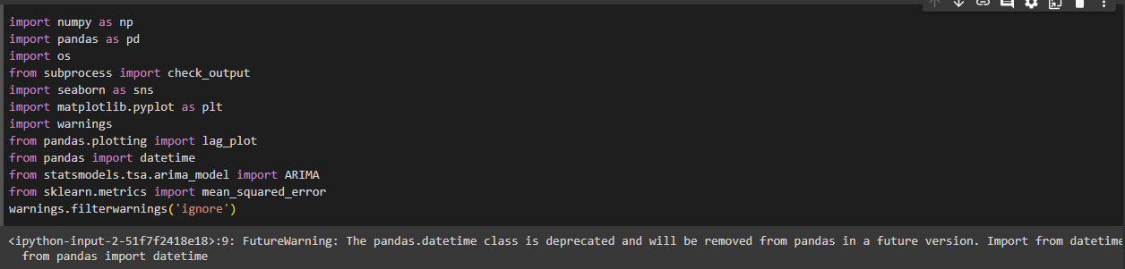

# Preprocessing:

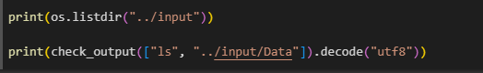

**Tesla Stock Market Analysis:**

# a.Import dataset and display the head of the dataset.

# 

# b.Display the shape and columns that is present in the dataset.

# 

# c.Display the closing price of the dataset.

# 

# d.Display the tesla cumulative returns.

# 

# e.Display tesla open price autocorrelation plot.

# 

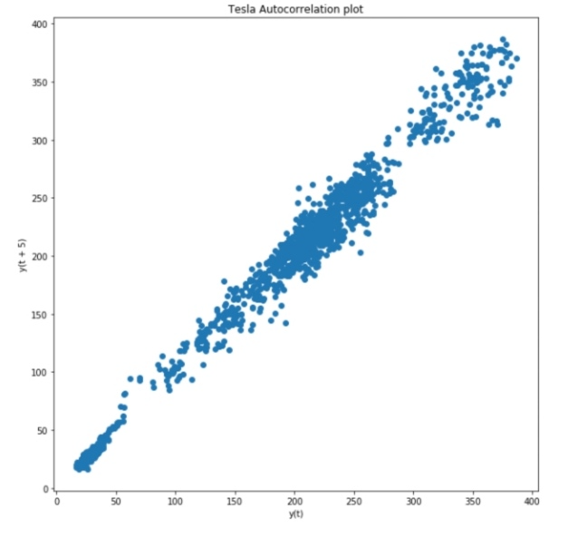

## **ARIMA (AutoRegressive Integrated Moving Average) for Time Series Prediction:**

**a.Tesla price prediction with training data.**

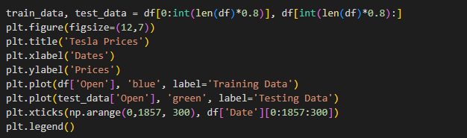

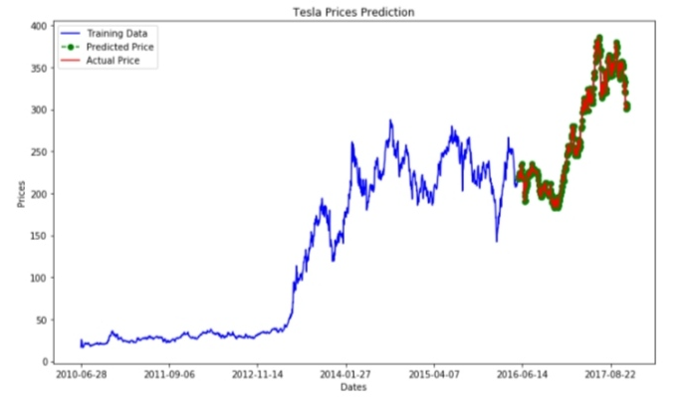

**b.Tesla prices prediction of actual and predicted values.**

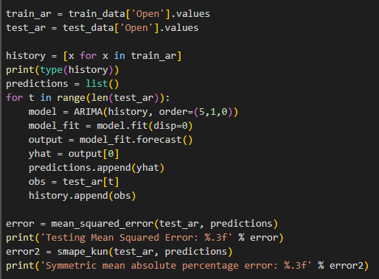

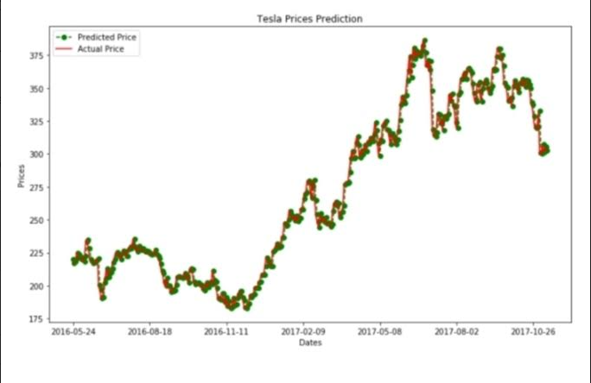

**Analysis helpful in the business:**

Stock prediction analysis findings can translate into valuable business insights by providing decision-makers with information that can be used to make informed and strategic decisions.

**Investment Decisions:** Stock prediction analysis helps businesses make better investment decisions. When the analysis predicts that a stock is likely to perform well, the business can decide to invest in it. Conversely, if the analysis indicates poor performance, the business may decide to divest or avoid that stock. This insight is critical for optimizing the return on investment.

**Risk Management:** Predictive analysis identifies potential risks associated with specific stocks. Businesses can use this information to implement risk management strategies, such as diversifying their portfolios, adjusting their asset allocation, or using hedging instruments to mitigate risks.

**Financial Planning:** Stock prediction findings can be integrated into financial planning. Businesses can incorporate these insights into budgeting, revenue projections, and long-term financial strategies. This helps in setting realistic financial goals and managing resources effectively.

**Strategic Partnerships and M&A:** When assessing potential strategic partnerships or mergers and acquisitions, stock prediction analysis can provide insights into the financial health and growth prospects of the target company. This information is invaluable in negotiations and decision-making.

**Market Timing:** Stock prediction analysis can provide insights into market timing. Businesses can make decisions about when to enter or exit the market, which can have a significant impact on overall portfolio performance.

**Quantitative Analysis and Trading Strategies:** For businesses involved in trading, stock prediction findings are critical for developing quantitative analysis and trading strategies. These strategies can be used for automated trading and for gaining a competitive advantage in the financial markets.